**API Testing using Postman**

**LECTURER**

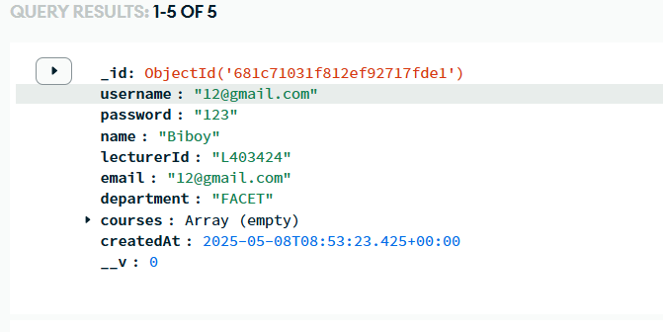

**STUDENT**

**ATTENDANCE**

